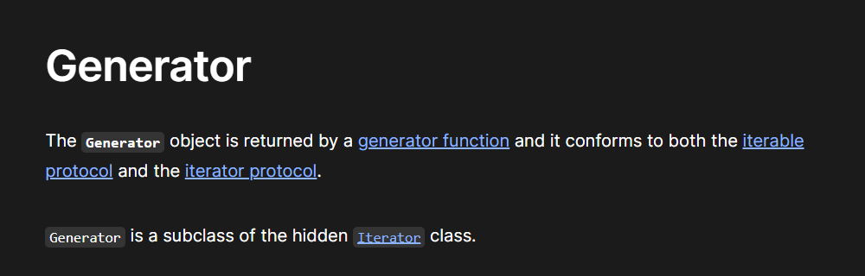

So, the **generator function** gives us the **generator object**

And, the generator object is iterable

Meaning it must have the next() method implemented with it

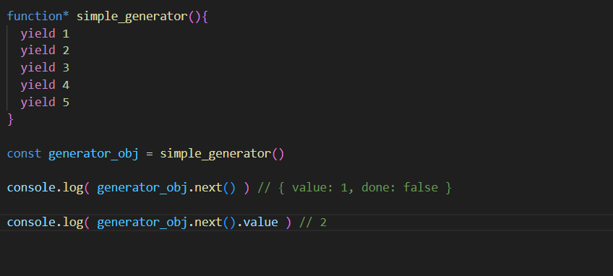

Here we use the keyword **“yield”**

As we know the objects aren’t iterables in javascript by default

Instead of defining our own iterator via [Symbol.iterator]()

We can do similar very easily using the generator

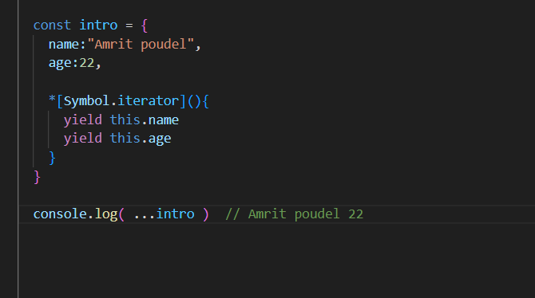

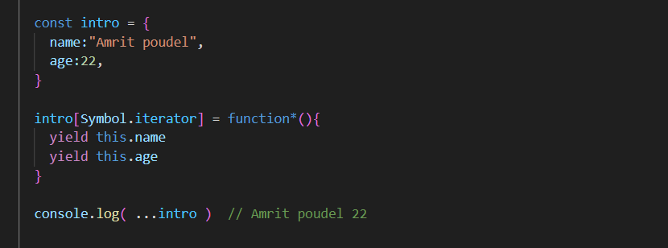

This is just basic we can do much more advanced things with generators

See those also